|  |  |  |  |
| --- | --- | --- | --- |
| Artifact ID:  CD-001 | Artifact Title:  Raspberry Pi Processor Definition | |  |
| Revision:  1.0 | Revision Date:  11 NOV 2019 | |
| Prepared by:  Joe Hansen | | Checked by:  Jesse Krage |
| Purpose:  The purpose of this artifact is to define the value of the Raspberry Pi as a processor for our design. | | |

# Revision History

|  |  |  |  |
| --- | --- | --- | --- |
| Revision: | Revised by: | Checked by: | Date: |
| 1.0 | Joe Hansen | Jesse Krage | 6 NOV 2019 |

# References

|  |  |  |
| --- | --- | --- |
| Artifact ID: | Revision: | Title: |
| N/A | N/A | N/A |

# Definition

The Raspberry Pi 3 is a small, single-board computer and a powerful tool that is widely used wherever a small computer has been needed to run a program and automate a task.

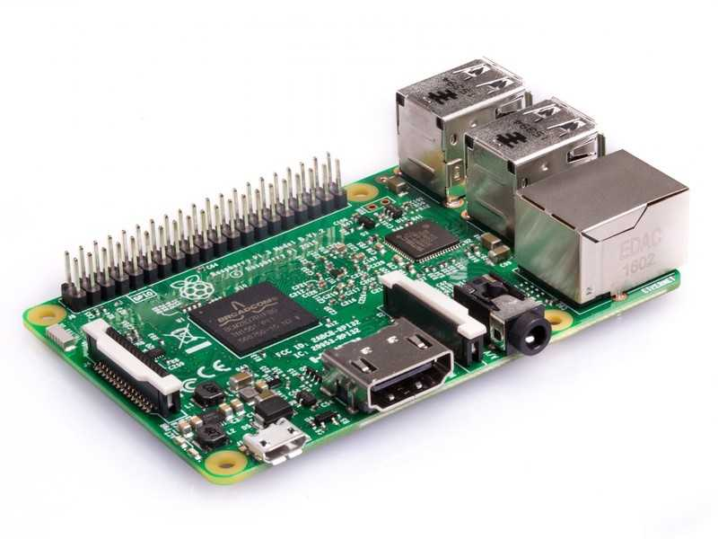

The Pi’s relevant value includes:

* HDMI output for troubleshooting and setup
* Ethernet out for communication over the network
* Wireless card for communication over wireless network
* 64-bit processor that is sufficient for all conceivable live calculations relevant to this project
* Vast array of useful documentation
* Small physical footprint

In our design the Raspberry Pi 3 will necessarily:

* Host a user interface
* Host a controller
* Facilitate the communication between those two
* Allow for communication over the network
* Fit into the existing tracker housing.

The controller software that we develop will need to access information from the user input device, run on the processor we choose, and be fast and reliable.

C++ is a great candidate for the language that our controller will be developed in. Our research has shown that there are existing libraries that can facilitate the interaction between most common web server software and C++. We are also more familiar with C++ than any other potential language.

There is a library that exists called FastCGI written in C++. This library is well-developed and facilitates communication between the browser-based server and the control software that exists on the system processor.